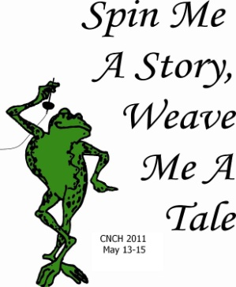
CNCH LIAISON LUNCHEON and Meeting
Saturday, September 18, 2010
Travel the trail to historic Sutter Creek to hear the tale of the exciting venue that waits for you at CNCH 2011. We invite all guild presidents and liaisons to attend.
LOCATION: J & D’s Steakhouse, 36 Main Street, Sutter Creek, CA
SCHEDULE: 10:00 – 11:45 CNCH Advisory Council Meeting
11:00 – 12:00 Luncheon Sign-in and pick up maps for walking tour of Sutter Creek
12:00 – 1:00 Luncheon served
1:00 – 2:30 Liaison meeting and CNCH 2011 Presentation
MENU: SALAD - Caesar salad
ENTRÉE - Your choice: Pasta Primavera – seasonal vegetables and mushrooms tossed with
linguine and a white wine sauce
Mixed Grill Skewers – prawns, steak, and chicken skewered with
pineapple, mushrooms, and red peppers on a bed of rice pilaf
Grilled Salmon – grilled salmon filet with a honey mustard glaze served
with seasonal vegetables and rice pilaf
DESSERT – Chocolate mousse
Reservations due before September 8, 2010
Send this form with your check payable to: CNCH 2011
Mail to: Dennis Keplinger, CNCH 2011 Treasurer, PO Box 4341, Fresno, CA 93744-4341
If you are not the correct person, or are unable to attend, please forward it to someone in your guild who can bring back the conference information to your next meeting.

Guild: ____________________________________________________________________________________
Attendee:____________________________________________Entree choice__________________________
Attendee:____________________________________________Entree choice__________________________

Number of attendees_________________X $25 each =______________________
Your Contact Information
Name:_______________________________________________________
Phone:_______________________________________________________
E-mail:_______________________________________________________

The CNCH 2011 committee looks forward to sharing plans with you for the upcoming conference. Plan to spend some extra time in this charming town exploring unique galleries and shops.

